All About Spheres
by Tom Chudleigh
Inventor, Manufacturer and Distributor of Free Spirit Spheres
The "Spherical Tree House" concept borrows heavily from sailboat construction and rigging practice. It's a marriage of tree house and sailboat technology. Wooden spheres are built much like a cedar strip canoe or kayak. Suspension points are similar to the chain plate attachments on a sailboat. Stairways hang from a tree much like a sailboat shroud hangs from the mast.
Spherical architecture has many unconventional features. Conventional buildings separate walls, ceiling and floor with hard lines. In a sphere the walls and ceiling merge into one. The function changes but the form remains the same. It is a unified structure with one continuous wall. I call this uniwall construction. There are only 2 sides to a sphere, inside and outside.

Bio-Mimicry
In bio-mimicry fashion, the nut like shape attaches to a web of rope. The web connects to which ever strong points are available. This replaces the foundation of a conventional building. A tree house sphere uses the forest for its foundation. The occupants have a vested interest in the health of the grove. The supporting web also mirrors our connectedness to our eco-system. Each sphere has four attachments on top and another four anchor points on the boom. Each attachment is strong enough to carry the entire sphere and contents
A suspended sphere is tethered by 3 nearly vertical ropes to each of 3 separate trees. This distributes the load evenly over the 3 trees and results in a stable hang. Like an inverted three-legged stool, there will be almost equal tension in each of the three suspension ropes. The sphere resides in the center of the triangle formed by the 3 trees. It can be slung from 5 to 100' off the ground, depending on the size of the trees. The triangle formed by 3 old trees was called a sacred grove in the druid tradition. Each grove was influenced by the type and age of the trees. I've found that to be my experience as well. The flavour of a grove changes considerably with the type of trees.
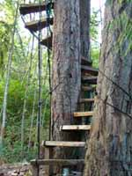 | A sphere is accessed by a spiral stairway and short suspension bridge. The two lower back suspension points of the sphere are tied horizontally to the two back trees, to keep the suspension bridge from sagging when it is walked on. The door faces the "door tree" and the suspension bridge connects the two. A helical stairway spirals up or down from the suspension bridge to the ground or next level. | 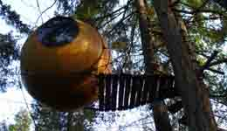
Externally the spherical shape is well adapted to life in the forest. A hazard of life in the forest is trees and branches falling in a strong wind or ice storm. A sphere distributes any impact stress throughout the skin and resists puncture or cracking. Like a ping pong ball or a nut, it's light with a tough skin. The suspension ropes which stretch also absorb some of the force.
The suspension concept is also bio-mimicry. The idea is to have the sphere and web function naturally in its environment. If something really big, like a tree, falls through the web then some strands will break and let it pass through. The sphere remains suspended by the remaining strands. A major disaster like that is not likely, but possible. Everything including spiral stairways and suspension bridges are hung from ropes. Trees are protected where the spiral stairways hug the trees and ropes pass around the trees. The spheres are well adapted to life in a large mature forest.

Interior
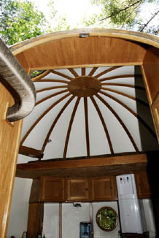
Both wooden and fiberglass spheres are insulated. Vinyl upholstery fabric is stapled to the frames (lines of longitude). Each fabric joint is then covered with a decorative wood strip. The wood strips come together at the top and give a nice cathedral ceiling effect.
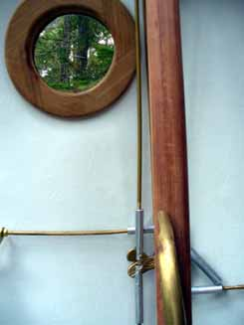
The joinery is yacht style with much brass trim, varnished wood and cane doors. They have closets on either side of the door. These function as partial bulkheads to reinforce the door opening as well as adding cupboard space.
In Eryn style, there is a double bed on the right centered under the 40" window. A settee with table is placed in front of the 42" window on the left. The back wall opposite the door provides a galley area with counter cupboards and a sink. A microwave and refrigerator are also installed.
Above the galley area there is a loft bed with full sitting headroom at the center. Circular shelf segments connect the loft bed to the cupboards on either side of the door.
More detailed photos of the interior feature can be viewed at the All About Eryn Photo Gallery.
Future dreams include a washroom/shower/sauna sphere complete with its own effluent treatment system. It will produce only clean water and compost, something that could serve a whole colony of spheres on a remote setting.
My personal goal is to produce 10 - 15 spheres and hang them all in a large area of old growth forest… a spiritual retreat for me and whoever else is interested.

