Are giant 'pinkhouses' the future of urban farming? Warehouses could be turned into year-round farms using artificial lights
- Researchers claim artificial lighting in warehouses could produce year-round growing
- Experiments being carried out using 'pink' lights - actually a mix of blue and red LEDs
- Could be used to grow food all year round in giant warehouses dubbed 'pinkhouses'
By Mark Prigg
PUBLISHED: 08:24 EST, 22 May 2013
The future of year-round farming could lie not in farms, but in huge warehouses lit with an eerie pink light, researchers have claimed.
Researchers have found that tomatoes grown around LED lights in the winter can significantly reduce greenhouse energy costs without sacrificing yield - and say the technique could change the way farming works.
One US firm is already experimenting with a giant warehouse in Texas, which hides a vast hi-tech pink growing area where 2.2 million plants will only see sunlight at the end of their life.
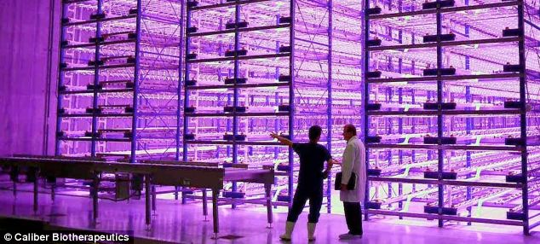
A giant 'pinkhouse' at Caliber Biotherapeutics in Bryan, Texas, which grows 2.2 million plants under the glow of blue and red LEDs - and could become the future of urban farming
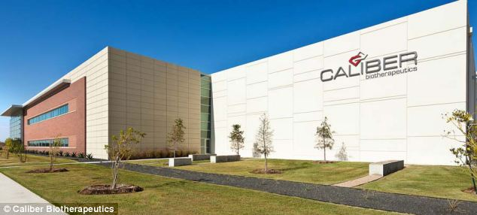
The giant warehouse which houses the 'undercover farm'

HOW IT WORKS
The 'pink' lights give plants only the wavelengths of light they need the most - blue and red.
Plant's photosynthesis machinery is tuned to absorb red and blue light most efficiently, so the researchers have developed systems to only supply this wavelength, lowering the cost of lighting systems needed.
The systems allow plants to grow perfectly normally without the need for real sunlight.
Caliber Biotherapeutics, a Texas firm, is already growing a tobacco-like plant to make new drugs and vaccines using the system.
The 150,000-square-foot 'plant factory' is completely closed off from the outside world, and is home to 2.2 million plants, stacked 50 feet high under the glow of blue and red LEDS.
'A photon is a terrible thing to waste,' Holtz told NPR.
'So we developed these lights to correctly match the photosynthesis needs of our plants.
'We get almost 20 percent faster growth rate and save a lot energy.'
Researchers at Purdue University say the technique could be used for producing crops all year-round.
Cary Mitchell, a professor of horticulture, said the average tomato is shipped about 1,500 miles from warmer climates where they are grown to cooler climates that cannot produce the fruit cost-effectively in the winter.
He believes that LED lights could mean growing all year round - and help local farmers compete.
'The United States still imports one-third of its tomatoes from Mexico and Canada, as well as other countries,' Mitchell said.
'It makes it really hard for the greenhouse industry to grow tomatoes well in the offseason.
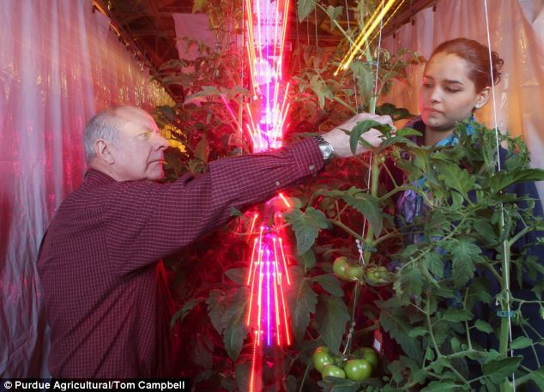
Cary Mitchell, from left, and Celina Gomez harvest tomatoes grown around red and blue LED lights, which use far less energy than traditional high-pressure sodium lamps in greenhouses
'We're trying to change that and make it affordable,' Mitchell said.
'This technology could allow U.S. growers to create local jobs that shrink carbon footprints and produce better-tasting tomatoes.'
Mitchell and doctoral student Celina Gómez experimented with light-emitting diodes, which are cooler and require far less energy than traditional high-pressure sodium lamps used in greenhouses.
They got the same yield - size and number of fruit - with high-pressure sodium lamps and LED towers, but the LEDs used about 25 percent of the energy of traditional lamps.
The scientists think that the method could have other advantages because the cooler LEDs can be placed much closer and along the sides of plants, lighting not only the top, but also the underside.
Future studies include comparing LED-lit tomatoes with traditionally grown tomatoes for flavor.

THE RISE OF PLANTSCRAPERS
Crops could soon be grown in greenhouses the size of skyscrapers in city centres across the country, it has been claimed.
Birds Eye and other food producers are investigating building ‘plantscrapers’, which could accommodate hundreds of storeys worth of crops, in a bid to make farming more economical, sustainable and meet increasing demand.
The ‘vertical farms’ would use an innovative feeding system which nourishes plants with enriched water, therefore cancelling out the need for soil – and the need for food to be grown and harvested in the countryside.
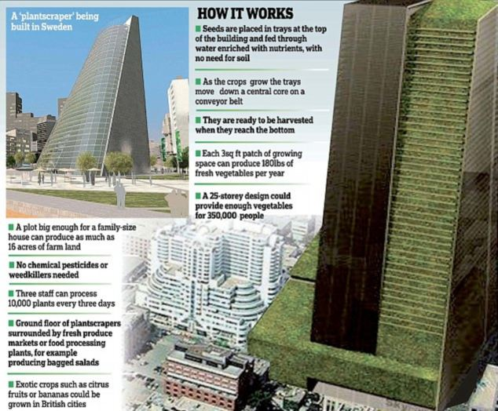
How the 'plantscraper' works
Because the climate inside them can be controlled, it is claimed the farms will dramatically increase crop yields because growing can occur all year round, while the plants would be under cover, so pesticides would not need to be used.
Some supermarket foods such as tomatoes and strawberries are already grown on farms using a primitive form of the so-called hydroponic system. Now there are sophisticated plantscrapers planned or under construction in Sweden, Japan, China, Singapore and Chicago in the U.S.
In Linkoping, Sweden, a 54-metre-high structure (just over half the height of Elizabeth Tower – home of Big Ben – in London) is being built by Swedish firm Plantagon.
By 2014, the structure will produce a range of leafy green vegetables, including salad leaves, spinach and mustard greens.
In Linkoping, Sweden, a 54-metre-high structure (just over half the height of Elizabeth Tower ¿ home of Big Ben ¿ in London) is being built by Swedish firm Plantagon

