Four Baby Whales Rescued in Florida
Megan Gannon, News Editor
Date: 06 September 2012 Time: 11:42 AM ET

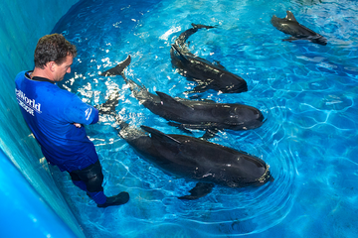
SeaWorld animal rescue team member Brant Gabriel supervises four juvenile pilot whales in the rehab pool at SeaWorld Orlando’s quarantine area. The whales are the only surviving whales from a mass stranding event on Saturday, September 1, that included 22 short-finned pilot whales at Avalon State Park.

Four rescued baby pilot whales have been taken to SeaWorld Orlando after washing up on a Florida beach. The whales, one male and three females, are the only survivors of a mass stranding that left 18 other whales dead.
On Saturday (Sept. 1), a pod of 22 short-finned pilot whales turned up at Avalon State Park Beach near St. Lucie on Florida's east coast. Volunteers and environmental officials responded to the scene to try to keep the whales — the largest of which was more than 25 feet (7.6 meters) long — hydrated and shaded.
But 17 died or had to be euthanized. The remaining five, all young whales, were brought to a rehab center at Florida Atlantic University’s (FAU) Harbor Branch Oceanographic Institute. There, they were treated for malnutrition, dehydration, stress and infection, FAU officials said.
One of the whales died Monday around noon after a rapid decline in health, according to FAU. The other four were taken to SeaWorld Orlando early Wednesday and placed in a quarantine area, where they will be cared for and tube-fed, a statement from the marine park explained. The caretakers hope to return the whales to the wild eventually, but a statement from FAU said the outlook for their survival "remains guarded."
Authorities are investigating the cause of the stranding and expect to get the dead whales' autopsy results in the next several weeks. Some officials speculate that one of the dominant adult whales became ill, stranded itself and the rest of the pod followed.

