#1. A New Relationship Between Men and Interior Design
Society is changing and its “movements” have collateral effects on all aspects of life as we know it. In developed countries, men are known to spend a lot more time at home than in the past, helping out with children and housework, as a result of the proclaimed men-women equality. In 2013, interior design will thus begin to mirror male preferences like never before.
Sober furniture details, less flashy colors and functionality over “cuteness” are just some of the features expected in a home with male dominance. If you think about it- strictly from an aesthetic point of view- this situation can create a great visual balance, one that will make both partners feel at ease in their own crib.
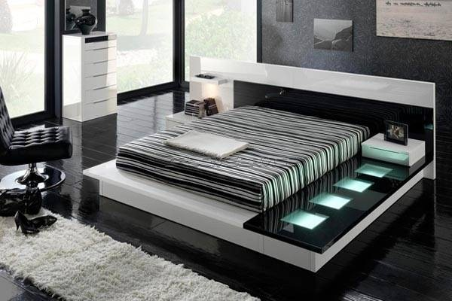

#2. Group Dynamics
Men being more involved in interior design is not the only social trend for this year. Another interesting shift will be made from personal tastes to group tastes and from a single designer to interior design teams. Efficiency will go sky-high, as project tasks will be well managed by more than one person.
For example, when it comes to designing a room, one team member could do the planning, another could take care of the lighting effects and the third designer could take on the finishing touches. Having more people dealing with a project is a good way to share responsibilities and speed up the work process for the client.
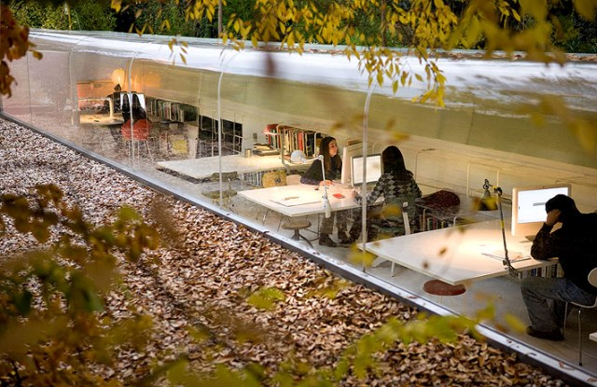

#3. DIY projects
Desire for self expression is more and more obvious in the houses of people everywhere. We want to have furniture and decorations that mean something, that make us smile and that ultimately make the place feel like home. Re-purposing various objects and materials is now both a passion and a form of art.
DIY projects are slowly starting to gain power in the process of interior design, whether we are talking about old chairs being revamped or new candle supports being created. Creativity is once again taken to the next level and the home owner is more than just an innocent bystander- he is now in complete control of the project’s outcome.
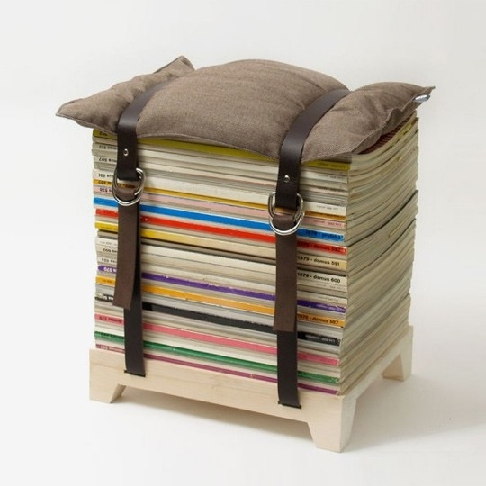

#4. Texture and Touch
If people did not pay much attention in the past to how a furniture object feels when touching its surface, this is probably due to the fact that functionality used to be the main sought after characteristic in a household item. Now things are much different. People are in search for “touchable” textures, which inspire warmth and comfort as a way to engage and experience a proper home atmosphere. Suede and wood are two of the materials which will define the interior design world in 2013. Variety of texture will also be a key factor in arranging spaces.
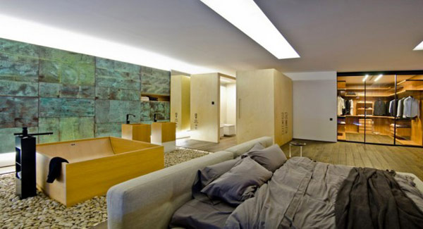

#5. Embroidery and knitting
It’s a shame we did not learn everything our grandmothers thought us; if we did, our homes would probably look a lot more cheerful right now. Nevertheless, embroidery and knitting is a major trend for 2013. From colorful carpets with thousands of knots to various storage baskets and poof covers, handmade is back and appears it will be here for a while.
The modern twist of these items produced by hand gives them a particular charm, one that can not be obtained from any industrially produced household decoration. Here are some thoughts on knitting and crocheting from a post we published on Freshome a while back.

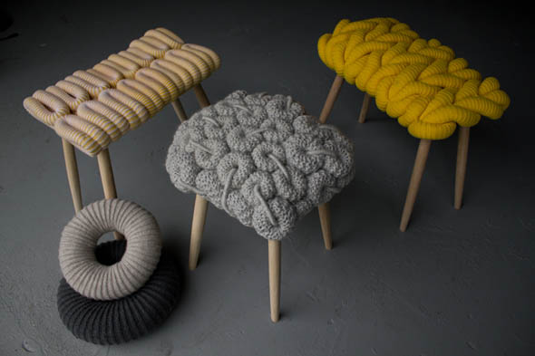

#6. Stripes, stripes, stripes
In 2013 social spaces will likely turn to design dynamics, in order to inspire vibrant living and energy. One of the most simple ways to achieve this effect is by employing stripes in an elegant manner. Carpets, wallpapers, upholstery, graphic art- each of these elements can wear the distinct feature of movement as long as they are defined by… stripes.
Bold red and black&white patterns are the highlight of the design themes again, only this time associated with minimalist decor complements. The idea is to make things stand out, without compromising in elegance or visual harmony.
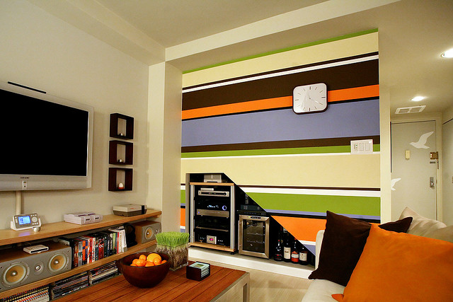

#7. Floral patterns with a white background
Floral patterns are also back in style, only this year they come with a twist: a white background. Ensuring a very romantic touch and giving the feeling of a perpetual holiday, these stylish additions make a strong statement in a room. You can go for a variety of colors, as long as the overall result is appealing. Try new fabric covers, graphic art, wall paintings and wallpapers- the effect will be pretty strong.
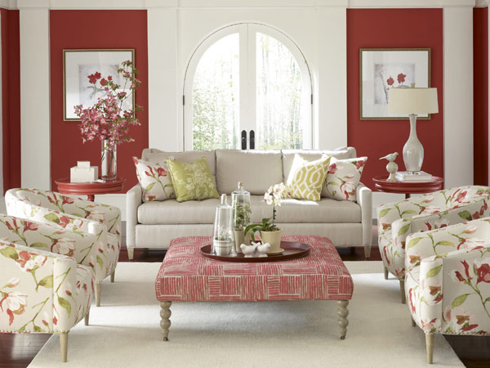

#8. African influences
More and more modern villas are starting to showcase unique design themes and African influences are particularly considered dynamic and “exotic”. In 2013, African influences are said to be a major trend, bringing warm colors and animal skin imitations back into the eclectic interiors of most fashion enthusiasts. In luxury holiday villas across the globe you will likely observe wooden furniture elements decorated with carvings or wrought iron, sculptures and handmade decorations, all defined by the African style.
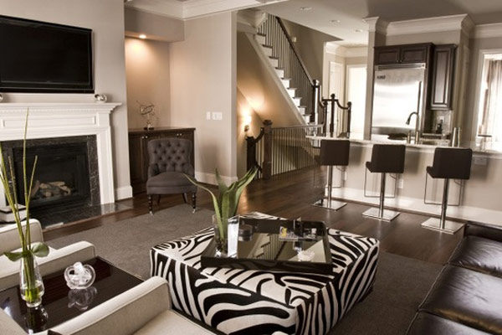

#9. Hand sketching and wall writing
We featured a post on Freshome a while back with some ideas on how to bring letters into your home. Hand sketching and wall writing will be more and more popular this year, as graphic artists will start collaborating with interior designers in creating original wall imprints. Imagine your favorite message elegantly written in the hallway or various letters adorning the ceiling. Here is a nice example below:

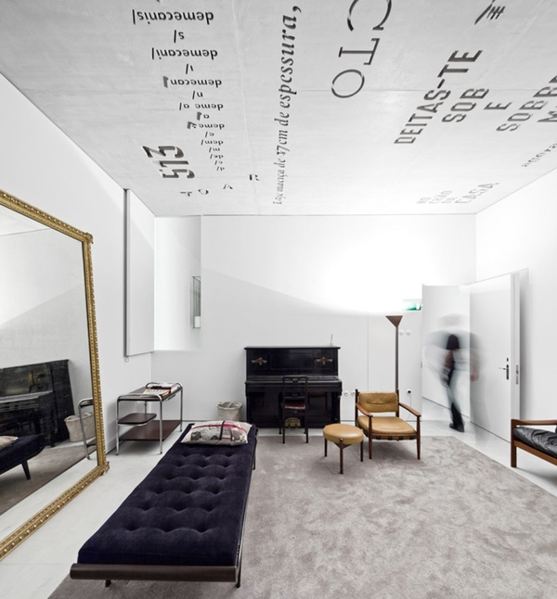

#10. Green walls, garden rooftops
Green living will be a key factor in design and architecture this year. From mobile plant panels to framed plant screens with lighting effects, this idea can bring a fresh touch to any apartment or public space. This approach is not only healthy, but also original and elegant. The advantages of having such a green wall? Air cleaning, humidification, evaporation of the air and appreciations from visitors. And here are 30 incredible garden rooftop ideas for further inspiration.
