- MEDIA CONTACT | SUBSCRIBE | SUBMIT A STORY IDEA
- EVENTS | CAMPUS | RESEARCH | GLOBAL | PEOPLE | HONORS | FYI | SPORTS
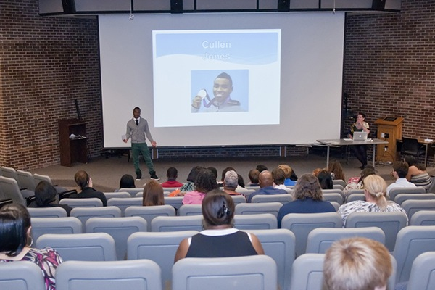
High school students at the EntrePrep Summer Institute present their business ideas at the "Business for a Day" segment.

Cultivating entrepreneurial minds

High school students try their hands at starting a business
11:55 a.m., Aug. 22, 2013--“I like making money,” Ebon Flagg said during his “Business for a Day” presentation to family, fellow participants and advisers at the University of Delaware EntrePrep Summer Institute.
Flagg and business partner, Miciah Mills, quickly picked up the concepts of supply and demand during this year’s program. Taking a cue from construction obstructions and high pedestrian traffic on East Main Street, the duo founded “Water Boyz” based on their prediction of a high pedestrian demand for inexpensive and easily obtainable water bottles.
“We made fifty something dollars,” Flagg said, after they ditched their original lemonade stand model and mobilized efforts by walking up and down East Main Street.
EntrePrep, a program administered by UD’s Center for Economic Education and Entrepreneurship (CEEE) with support from both the Delaware Department of Labor and TD Bank, took place over the course of a week earlier this month. Throughout the week, students worked to research business ideas and measures for success before launching their projects during the “Business for a Day” segment.
“This is a program designed to have young people discover their potential,” said Jim O’Neill, director of the CEEE. “They brainstorm, discover their respective strengths through collaboration and ultimately decide on a product they can market for Business For a Day.”
Some students realized that working for an already established company as a consultant might turn greater profits.
The students of “Illustrated Serendipity” decided to make a commercial for Penguin Ads, a local business that specializes in finding drivers willing to motor around with company logos and advertisements on their cars.
The students believed a commercial would make more people aware of Penguin Ads and ultimately impact the company’s goal to get more cars to carry more advertisements. As part of the business deal, as Penguin Ads made more money, “Illustrated Serendipity” could receive a cut of the increased profits.
Reflecting on the experience, one of the teammates suggested communication was key to having a successful team and avoiding conflict among team members. Said another of testing out a business idea, “You feel like you accomplished something great.”
For Teyisha Broadway and Allie Thompson, creating a business for a day meant using their already-known talents to make bracelets from durable but stylish materials. Their marketing strategy for “Survival Bracelets” involved using a name that highlighted both product fashion and usefulness.
Like the “WaterBoyz,” Thompson and Broadway sold 23 bracelets by walking up and down East Main Street.
The team also pre-sold bracelets to other EntrePrep participants, for a total of $138 in sales.
“We learned there are different ways to make money and to get there it takes a lot of work,” Thompson said.
Broadway added she and her teammate also stumbled upon an important lesson in Robert Kiyosaki’s book, Rich Dad, Poor Dad: “Don’t forget to pay yourself,” she said.
Mills’ mother presented flowers to Carrie McIndoe, who runs the EntrePrep Institute, and her assistant, Mary Sharkey, once the presentations concluded.
“As a parent, my husband and I have benefitted from the program,” said Mills’ mother. “We have five children who have gone through the program. In the end it is about starting your own business as much as it is about the students finding themselves.”
Article by Christopher Pinti

