New Egyptian company explores culture through fashion
Wednesday, 06 February 2013
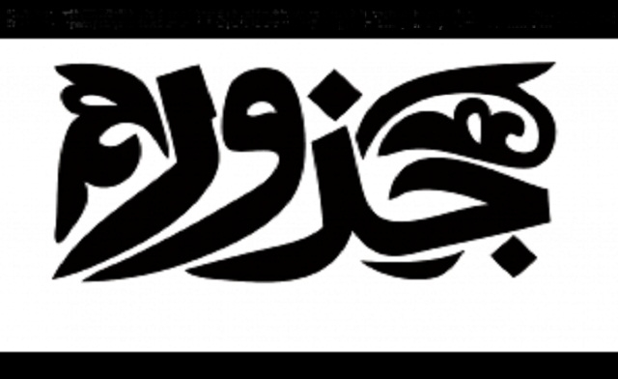
The Gozoor project started four years ago when movie director, and company founder, Mohamed Nassar made a documentary on what he calls “the chaos of clothes” in Egypt. (Image courtesy: Gozoor.org)
By AL ARABIYA
Gozoor is a newly-established Egyptian company that explores the country’s identity and culture through fashion, local media reported.
Many Egyptian artists have tried to capture the elusive nature of their identity through such mediums as art and cinema, one famous account was Shady Abdel Salam’s dream-like masterpiece, The Night of Counting the Years.
The Gozoor project started four years ago when movie director, and company founder, Mohamed Nassar made a documentary on what he calls “the chaos of clothes” in Egypt.
“I was exploring the Egyptian loss of identity and marginalization but the information accumulated and evolved into Gozoor,” he said.
The company is made up of four components: a fashion school, a fashion show, documentary films, and media services, al-Bawaba reported this week.
“The fashion show’s purpose is to bring Egyptian designers to the forefront that focus on Egyptian identity and heritage,” Nassar explained
Gozoor is attempting to define the national identity by promoting an acutely Egyptian sense of fashion.
The company’s mission statement includes the discovery and promotion of contemporary Egyptian fashion through specialists, researchers and university professors to create authentic Egyptian designs.
The school is also seeking to discover new talent in Egyptian fashion, and support them through different stages of the industry- study, production and marketing, according to the official website.
Gozoor is organizing a fashion week to take place outside Egypt as a promotion of the culture, it is also a bid to open channels to the global market.
“Dress is one way culture is expressed. For example, you have two extremes in Egypt such as Niqab and veil and then what we call Shakira’s veil, a fusion of western and Wahhabi. This juxtaposition speaks of a nation whose culture cannot be defined in one particular way. As of late, Egyptians have been focusing too much on Arab and Islamic identity but ‘Egyptian’ is an identity in and of itself. You cannot take one part and leave the other,” said Nassar, quoted by Daily News Egypt.
Nassar states that there is currently no Egyptian fashion scene and there is no style of clothing that distinctly reflects the age-old Egyptian culture.
Besides Egypt, Gozoor also plans on exploring other Arab cultures in the countries of North Africa.
“There is much more diversity in places like Tunisia and Morocco than there is in the Arab peninsula so we have chosen to explore this region,” Nassar said.
Gozoor’s first workshop is scheduled for February, with the exact date still to be announced. “Our first workshop will be a familiarization with what we aim to do. Since our workshops are free to attend, registration is likely to close up quickly, and we only plan on taking 10-15 people per workshop,” Nassar stated.
Planned workshops will showcase the work of four designers, from different parts of the world, and will highlight how their clothes represent their country’s heritage.
Gozoor attempts to cater to people of all ages and backgrounds.
“We have flexible hours and all our activities are aimed at teaching culture and spreading cultural awareness. We hope that with time, we will have students and products that reflect our own trends, heritage and identity,” explained the founder.

