Students head for solar car contest
Submitted by Northwestern News on Tuesday, June 8, 2010, at 10:40 am
A team of Northwestern University students head for Texas Thursday for a week of qualifying trials to prepare their solar-powered car for a planned 1,200 mile cross-country race later this month.
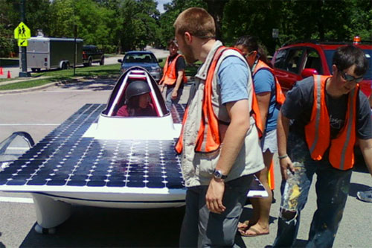
NUsolar team members work on preparing their car.
The 30 undergraduate students on the team have worked for months, and in some cases years, to demonstrate that solar energy is a viable green technology right now.
The NUsolar team plans to race against teams from universities around the world in the American Solar Challenge, from June 20 to 26, that will run from Tulsa, Okla., to Naperville, Ill. They expect to hit speeds around 40 mph.
Northwestern's team, with students from a range of schools and disciplines, has worked nonstop on the vehicle during the past two years, creating a car with a lightweight body constructed from Boeing carbon fiber.
The vehicle, called sc5 -- because it's the fifth solar car NUsolar has built over the past dozen years -- is powered by 21.5 percent efficient SunPower solar cells and also harnesses the latest lithium-ion battery technology.
The demanding race is seven full days of pressure, thinking on one's feet and teamwork. Along the race route team members will work in a variety of areas, including analyzing the stream of data received from the car, strategy and determining the optimal speed, mechanical and electrical troubleshooting and keeping an eye on the weather. The team also will be reporting its daily progress using Facebook, Twitter and a blog.
The American Solar Challenge is run much like the Tour de France with the cars traveling a set distance each day. Individual times are recorded and added up throughout the seven days of racing. The best total time wins.
The race requires four drivers from each team to take turns driving their cars hundreds of miles every day. Team members must consider sunlight and battery power to determine how fast and long they can go each day.
Northwestern's car can run for about three to four hours off a fully charged battery; the car also charges while it races but is dependent on how sunny or cloudy the day is. Teams are allowed two hours each morning to charge their batteries, followed by nine hours of racing, with the day ending with two more hours of charging time.
"Solar cells are pretty finicky -- they like direct sunlight, so weather is a big factor in capturing the energy we need," said Phillip Dziedzic, project manager for NUsolar and a senior in the McCormick School of Engineering and Applied Science. "Efficiency is foremost in our mind during the race."
NUsolar will be racing an improved version of the car they raced in the 2008 American Solar Challenge. Dziedzic says the goal this year is to have better reliability and to race at a higher speed -- an average of about 40 mph instead of the 30 mph two years ago.
The students on the NUsolar team aren't just from the McCormick School of Engineering -- a number of them are from the Weinberg College of Arts and Sciences and the Medill School of Journalism.
"The solar car is a really complex project, and we are running it like a business," said Michelle Loret de Mola, public relations chair and a Weinberg freshman. "We need engineers, business people, communicators and managers to be successful. The solar car is a continuous project -- 365 days a year -- and our emphasis is on learning, not just winning."

