The Future of Farming: Eight Solutions For a Hungry World
The challenge of growing twice as much food by 2050 to feed nine billion people—with less and less land—is everyone’s problem. But scientists are hard at work fomenting a second green revolution.
By Hilary Rosner Posted 08.07.2009 at 11:45 am 53 Comments

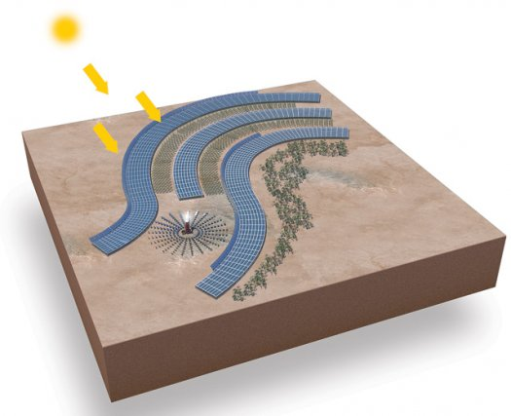
Desert Oasis The Sahara Forest Project will use concentrating solar power to provide energy to greenhouses in the desert. Paul Wootton
Today’s crops crisscross the globe: Mexico’s tomatoes end up on your plate, our wheat heads to Africa. As a result, the challenge of growing twice as much food by 2050 to feed nine billion people—with less and less land—is everyone’s problem. But scientists are hard at work fomenting a second green revolution. Here’s how nitrogen-spewing microbes, underground soil sensors and fruit-picking robots will help keep food on our tables.

1. Farm the Desert
70%: Amount of the world’s freshwater used for agriculture
Solution Greenhouses built near coasts turn plentiful seawater into freshwater for crops, without expensive desalinization plants.
Potential Farmers could grow cash crops like lettuce and tomatoes in the desert.
ETA Three pilot projects are under way, and researchers are scouting sites for a larger full-scale project.
On frequent trips to Morocco, British lighting designer Charlie Paton was struck by the juxtaposition of sea and vast, sweeping desert. “You’re on the edge of the Sahara but so close to the ocean,” he says. After selling his lighting company, Paton set about designing something that brings the two together: the Seawater Greenhouse, a low-energy means of growing food in desert regions using abundant nearby saltwater. Three pilot greenhouses in Tenerife, the Canary Islands; Abu Dhabi, the United Arab Emirates; and Oman use prevailing winds, fans and simple evaporators to convert seawater into fresh, and in the process create a humid environment in which just about any plant can grow.
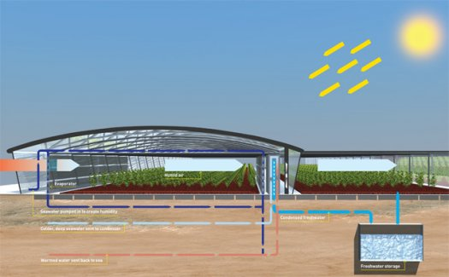
Growing Plants with Saltwater: Seawater Greenhouse evaporates seawater into humid air for plants and then condenses it into freshwater for watering. Paul Wooton
The greenhouses, which will cost as little as $5 a square foot to build, get water from the sea, either by gravity or a pump. The water trickles down honeycomb-shaped lattices on the front wall and evaporates, cooling and humidifying the air inside. The air warms as it travels across the greenhouse—hotter air can hold more moisture—before reaching a second evaporator, which supersaturates it. From there, the air moves immediately into a condenser, which pulls out freshwater and sends it to an underground storage tank for watering the plants.
Paton is now scouting locations for the Sahara Forest Project, which will add a “concentrating solar power” plant to the greenhouse concept. Extra freshwater could then be used to run the facility (the sun heats water in pipes to make steam, which drives generators) and to clean the huge arrays of mirrors.
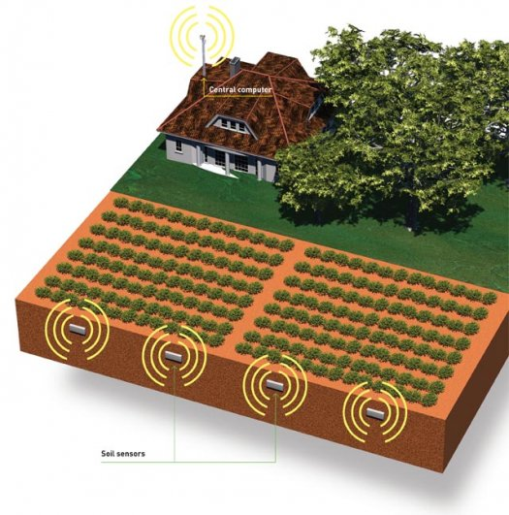
Dirt Cheap: Underground soil sensors give farmers a real-time view of their fields' conditions Paul Wootton

2. Growth with Precision
300 to 500 pounds: Amount of fertilizer American farmers use per acre, at a cost of 40 to 80 cents per pound
Solution Networked soil sensors signal how much fertilizer and water are needed and when.
Potential Slash the amount of resources required for farming
ETA Five years to commercialization
With today’s “precision agriculture,” GPS-steered tractors can apply fertilizer and water to seeds with sub-inch accuracy. Now farmers can be as exacting with the amount and timing of the application. Stuart Birrell, an associate professor of agricultural and biosystems engineering at Iowa State University, teamed up with his colleague Ratnesh Kumar, a professor of electrical and computer engineering, to design a network of underground soil sensors that stay in the field year-round.
The sensors continuously measure moisture, temperature and nutrient data and transmit the information wirelessly back to a central computer. “There are some wireless systems out there,” Birrell says, “but most of them need an antenna, so they’re prone to being knocked down by farm equipment.” Birrell and Kumar’s sensors are planted in the field, a foot deep, in a grid 80 to 160 feet apart. They beam the data through the dirt using low-frequency radio signals. The iPod-size sensors will help farmers reduce fertilizer usage, because water and temperature provide clues to how nitrogen and carbon are cycling through soil. Planting four to six sensors per acre would cost farmers $20 or $30, Kumar says, but the savings on fertilizer, water and other resources could add up to $150.
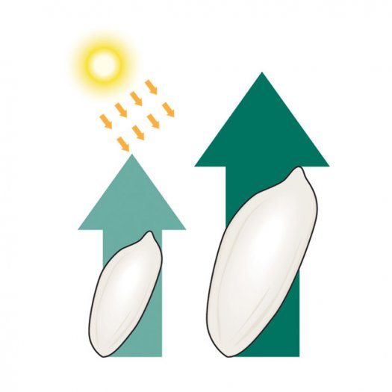
It's a Bird...It's a Plane...It's Super-Rice!: Altering the way it uses the sun's energy, super-rice grows faster. Paul Wootton

3. Rebuild Rice
50%: Amount of the world’s population that depends on rice as a staple crop
Solution Genetically engineer rice to change its photosynthesis, so we can grow more of it in any conditions.
Potential Increase rice yields by 50 percent per year,
and learn how to transform other plants as well.
ETA As soon as 10 years
To call what John Sheehy is doing to rice genetic modification is an understatement. Sheehy, the head of the applied-photosynthesis lab at the International Rice Research Institute in Manila, Asia’s largest nonprofit agricultural research center, is changing the most fundamental quality of rice: He’s altering the way it uses the sun’s energy to make it grow faster. It’s like making the human digestive system twice as efficient at processing food.
Sheehy and his team are engineering a super-rice by turning it into a so-called C4 plant. Most plants, including rice, perform a type of photosynthesis (the basic process taught in high school, in which plants use sunlight, water and carbon dioxide to make energy-packed carbohydrates) known as C3. But C4 plants, including corn and sorghum, build tissue more efficiently in warmer and drier climates by using a different process to create those carbohydrates that require less CO2. That reduces the amount of time the plants need to keep their leaf pores open to soak up the CO2, so they lose less water to evaporation.
As for how to make such a transformation, scientists know that C4 capability has evolved many times in the past, so the plan is simply to mimic nature. To do that, Sheehy and his team must determine which genes regulate C4 leaf anatomy and essentially evolve a more productive kind of rice. Once they crack the code, the same techniques could eventually be used to turn other crops into C4 plants—for instance, wheat grown in sub-Saharan Africa.
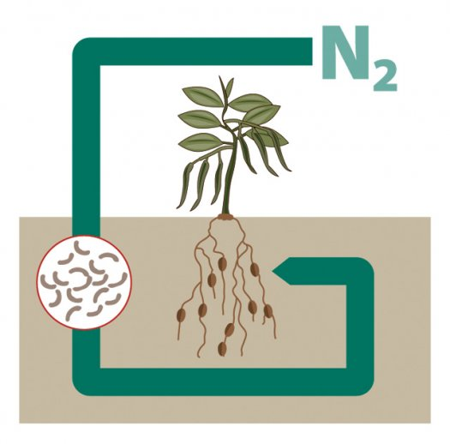
Fertilizer on Steroids: A liquid soil additive called Bio-Soil Enhancers boosts yields in virtually every type of crop. Paul Wootton

4. Replace Fertilizer
1.2%: Amount of global greenhouse-gas emissions caused by the production of chemical fertilizers
Solution Seeding fields with microbes that pull nitrogen from the air
Potential Increase yields while leaving soil healthier than before
ETA Small quantities available now
Fertilizer use has exponentially increased crop yields in the past 30 years. That fertilizer provides extra nitrogen, phosphorus and potassium, which are essential for plants to build amino acids and cell walls. Soon, farmers may be able to get all the benefits of man-made fertilizer for hundreds of dollars less by using microbes instead. C.A. Reddy, a professor of microbiology and molecular genetics at Michigan State University, examined 300 naturally occurring soil microbes and assembled a cocktail that can simultaneously reduce the need for phosphorus and nitrogen fertilizers, protect plants against pathogens, and boost yields in virtually every type of crop.
In his experiments, field-grown tomato plants fed with his microbes produced nearly 90 percent more fruit, and greenhouse tomato yields were often even greater compared with using traditional fertilizer. He’s also tried them on plants ranging from eggplant to switchgrass. Sold as a liquid soil additive called Bio-Soil Enhancers, Reddy’s microbes are self-sustaining, unlike traditional fertilizer, which needs to be replenished every year. He’s doing extensive field trials now.
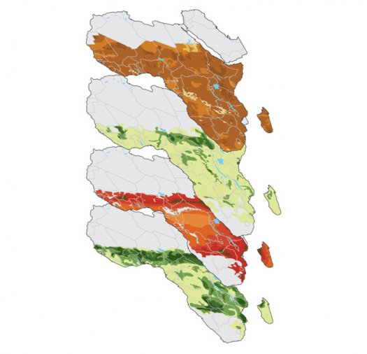
Deep Data: New mapping efforts chart information like irrigated area and crop distribution. Paul Wooton

5. Re-Map a Continent
0: Increase in per-capita food yields in sub-Saharan Africa over the past 40 years.
Solution Gather extensive data on land use to better target new farming technologies
Potential African farmers will increase yields enough to feed a local population expected to double by 2050.
ETA 2010
Suppose you work for a large foundation trying to alleviate malnutrition in sub-Saharan Africa. You want your project to have the maximum impact. Are you better off funding irrigation projects, higher-yielding seeds or pest-resistant crops?
That question is why the Bill and Melinda Gates Foundation gave $4.7 million to HarvestChoice, a massive open-source effort to gather and merge more data than ever before—archived government surveys on household composition, climate information to help map crop potential, theoretical models of development patterns. The goal is to create a complete virtual library of Africa’s agricultural systems. As the data pours in, HarvestChoice generates maps layered with information and produces simulations of how different solutions might play out. “You wouldn’t be investing in dairy farms where it would take six hours to get to market over bumpy roads,” says Stan Wood, co-leader of HarvestChoice for the nonprofit International Food Policy Research Institute.
Meanwhile, NASA has teamed up with the U.S. Department of Agriculture to use its Aqua satellite to monitor soil moisture around the globe. Crop yields are determined in part by how much water the ground holds. The satellite collects data on the amount of microwave radiation emitted by the land, which scientists combine with information about vegetation cover and soil temperatures to figure out how much of the radiation is coming from water in the soil. The USDA’s Foreign Agriculture Service is using the data to help form more-accurate crop forecasts for the U.S. and for developing countries, where ground data is often sparse. In 2013, the project will get a boost from the Soil Moisture Active and Passive satellite, which will provide information at a much more detailed scale than Aqua.
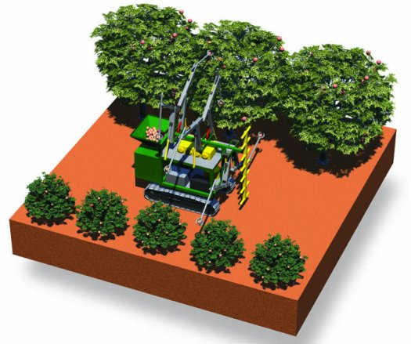
Future Farmhands: Someday, robots could replace humans for picking delicate fruits and vegetables. Paul Wooton

6. Use Robot Labor
$55 billion: Value of the specialty-crop industry—apples, grapes, pears and other delicate produce—which relies on a declining number of available human hands to harvest
Solution Mechanized farmers for monitoring, pruning, thinning, and even picking produce
Potential Domestically grown fruits and veggies everyone can afford
ETA As soon as two years

Related Articles
 | Plant to Farmer: “Water me!”
 | In Food Shortage, The World Looks to the Potato
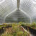 | Ole! Spanish Greenhouses Make Climate Less Caliente

Tags
The Environment, Feature, agriculture, August 2009, cassava root, charcoal, evaporators, food crops, greenhouse, lawn fertilizers, methanol, nutrient enri, rice, robots, Sahara, satellites, seawater, soil conditions, solar power, usda foreign agriculture service, wireless networks
While the banking and automotive industries implode, fruit and vegetable growers are fending off a financial crisis of their own. Tough immigration laws, among other factors, are shrinking the labor supply for picking delicate crops, in some cases leaving millions of dollars of produce unpicked. As part of an unofficial bailout, the USDA recently awarded $28 million to Sanjiv Singh of Carnegie Mellon University and other researchers around the country in part to build automated farming systems that will improve fruit quality, shore up worker shortages and, it’s hoped, keep American fruit farmers solvent.
Singh and his team are field-testing future farmhands on a patch of ground just outside Pittsburgh. Autonomous four-wheelers rumble through apple orchards, using sensors to scan for things like fungus and growth rates. Separate sensors in the ground monitor soil moisture, humidity and light levels. “People who own thousands and thousands of acres simply can’t monitor all of their crops,” Singh says. In the future, farmers could micromanage every plant from a central station, and dispatch robots to deal with pest invasions or soil imbalances before any fruit starts dying.
But can robots roll up their figurative sleeves and pick fruit? Vision Robotics, a company in San Diego, thinks so. It’s building scouting robots that use multiple stereo cameras to locate and size the fruit in the trees. The ’bots beam that info to robotic fruit pickers that look like mechanized octopuses on tank treads with long harvesting arms that gently pluck the produce. For now, the speed and accuracy of the machines still lag behind their human counterparts, and they still cost far more to employ. For Singh, that’s a deal-breaker: “It would be 15 minutes before [farmers] would start asking, ‘How much does it cost?’ If a robot is 10 times as expensive or 10 times as slow as a human, then it won’t work.”
The near-term practical answer, he argues, is machines that allow fewer people to do more work—scissor lifts for better access to treetops, automated pruning devices, robots that stack and transport boxes and, of course, a sensor network to keep it all in sync. Old MacDonald, meet the
21st century.—Nicole Dyer
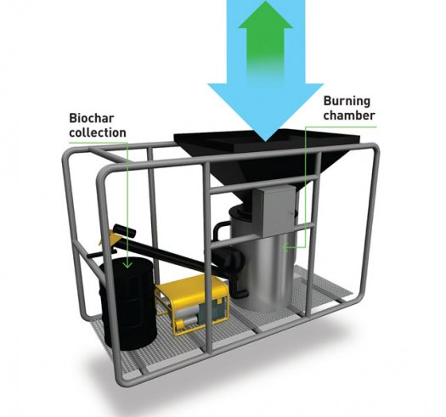
Charcoal Maker: Slowly combusting biomass in a low-oxygen environment yields nutrient-rich charcoal. Paul Wooton

7. Resurrect the Soil
25%: Amount of land, globally, that’s been degraded by human activities
Solution Add biochar, a form of charcoal that provides plants with vital nutrients while also sequestering carbon.
Potential Turn vast swaths of unfarmable land arable again, while locking away tons of carbon dioxide.
ETA Available now (see our recent report on homebrewing Biochar in Brooklyn)
Pre-Columbian Amazon tribes cleared and then slowly burned swaths of forest and mixed the charcoal into their soil, creating rich, dark dirt called terra preta. Today that charcoal is known as biochar (and is made from waste, not rainforests). It could simultaneously make farming more sustainable and turn agricultural fields into vaults for storing carbon. Biochar attracts microorganisms that help plants access nutrients in the soil, and it enables the ground to hold more water. Better yet, it locks the carbon in the biomass rather than letting it escape back into the air. Modern methods for making biochar decompose the plant waste by heating it at super-high temperatures in low oxygen.
The challenge for soil scientists is to determine the best raw materials and process for making biochar. Each yields its own type of charcoal with different nutrients. Some methods also produce bio-oil and “syngas” that could be sold
to offset the costs.
A handful of start-up companies are building equipment for making biochar at scales suitable for villages to industrial farms. One of the first to market is Biochar Engineering in Colorado. Its shipping-container-size machines are portable so that farmers can produce biochar onsite, eliminating the need to haul biomass to a central location. Gases containing hydrogen, nitrogen and carbon monoxide are fully burned in a separate process, generating heat to run the cycle. Eventually, add-on modules could produce liquid fuel, such as methanol, in addition to the charcoal.
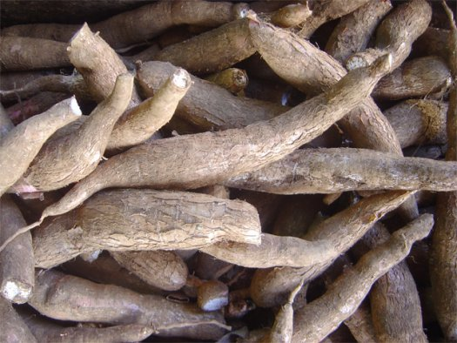
Transgenic Cassava: Scientists are turning the vitamin-deficient root into a Powerbar of the vegetable world. Courtesy David Monniaux

8. Make Supercrops
1/3: Proportion of malnourished people in Africa
Solution Engineer the cassava into the perfect crop
Potential An African-made plant with 10 times the nutrients of the current cassava
ETA 2015
Cassava root is cheap and grows in even the worst conditions. That’s why 250 million people rely on it as their staple food. So scientists are aiming to make it the PowerBar of the vegetable world: everything a body needs in one bite. It’s a big job. Cassava is deficient in iron, zinc, vitamin A and vitamin E. It also rots in two days, so farmers can’t grow extra to sell.
BioCassava Plus is a $12-million effort at the Donald Danforth Plant Science Center in St. Louis to develop a cassava with more nutrients, longer shelf life, extra virus resistance, and no cyanide-producing toxins in the root.
So far, scientists have produced individual strains with four times the protein, 10 times the vitamin E or eight times the zinc. The next step is to stack the genes together in a single plant, using the varieties that Kenyan and Nigerian farmers prefer. The program recently received approval for the first-ever field trial of a transgenic crop in Africa.

