The Sims 4 Is Happening in 2014
By Matt PeckhamMay 06, 2013
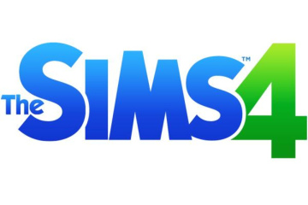
Electronic Arts and Maxis just pulled back the curtain on something as inevitable as death, taxes and “always-online” requirements: Yes, The Sims 4 is officially a thing, and it’s coming in 2014. Incidentally, the domain name for thesims4.com was originally registered back in 2003, but someone updated the WHOIS record on April 6, 2013, fueling speculation a product announcement was imminent. Sure enough…
Maxis isn’t saying much else at this point, other than specifying platform type — PC and Mac, no mention of consoles — and adding this bit of self-congratulatory ballyhoo:
The Sims franchise is fueled by the passion and creativity of its millions of fans around the world. Their continued devotion to the franchise ignites the fire of creativity of the team at The Sims Studio, driving them to continually improve and innovate on one of the world’s most successful simulation game that has sold more than 150 million copies worldwide.
EA says it’ll release more info later today on its blog, “The Beat,” and it’s urging readers to wax ebullient in the meantime while referencing #TheSims4 via Twitter.
Update: The press release is live, including a few words clearly meant to reassure players shellshocked by their experience with SimCity‘s, umm, connectivity requirements:
…The Sims 4 celebrates the heart and soul of the Sims themselves, giving players a deeper connection with the most expressive, surprising and charming Sims ever in this single-player offline experience. The Sims 4 encourages players to personalize their world with new and intuitive tools while offering them the ability to effortlessly share their creativity with friends and fans.
Read more: http://techland.time.com/2013/05/06/the-sims-4-is-happening-in-2014/#ixzz2VBK9SzRD

